Barber Inbound & Outbound Voice Automation System
GoHighLevel | Synthflow | Voice Agents | CRM | Inbound & Outbound Calling | Appointment Booking

Project Overview
Built a GoHighLevel automation system for a barber business to manage inbound and outbound calls, appointment bookings, post call data, and customer communication.
The setup connects voice agents with GoHighLevel workflows so call activity and appointment information are handled directly through the CRM.

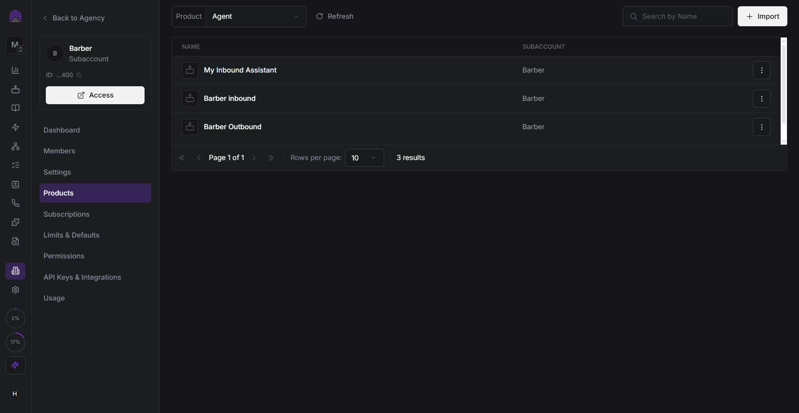
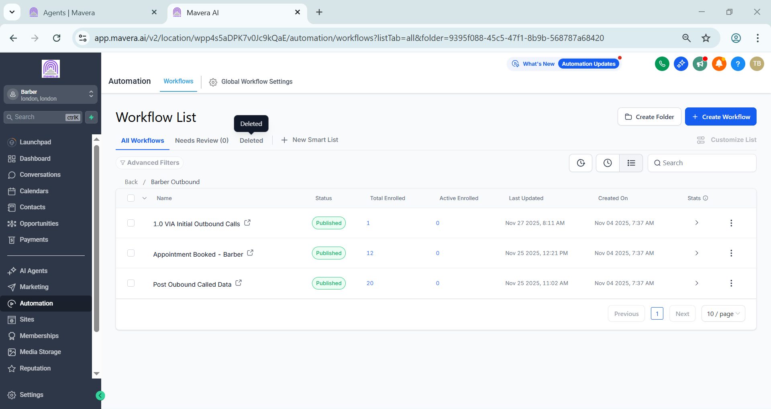
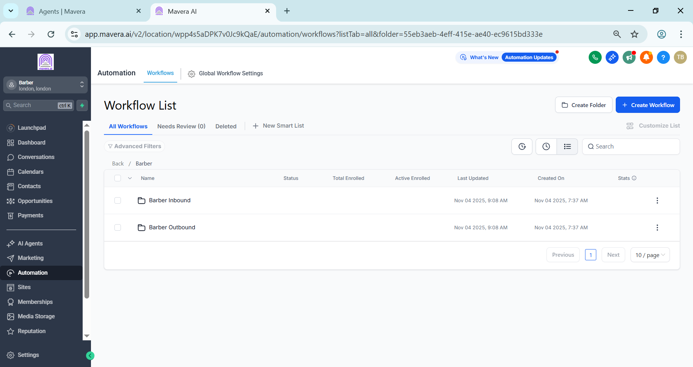
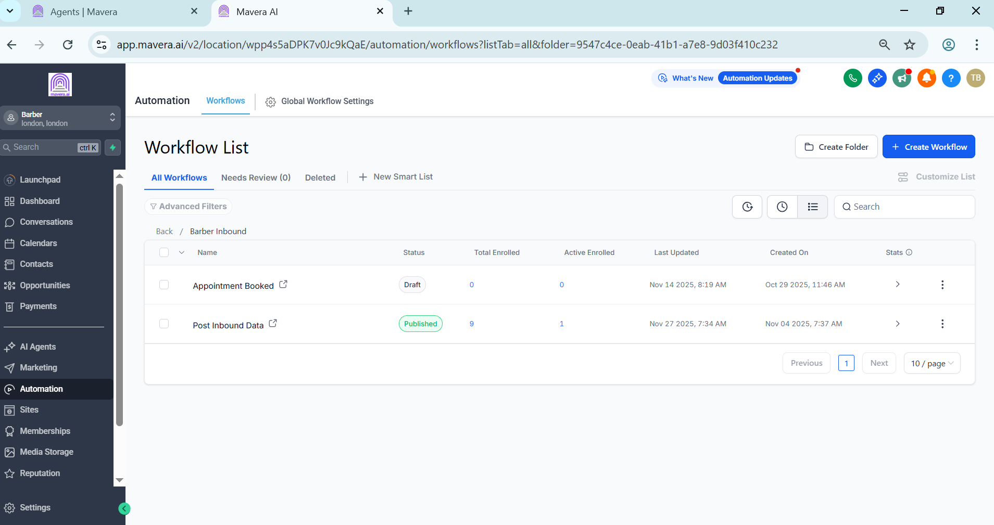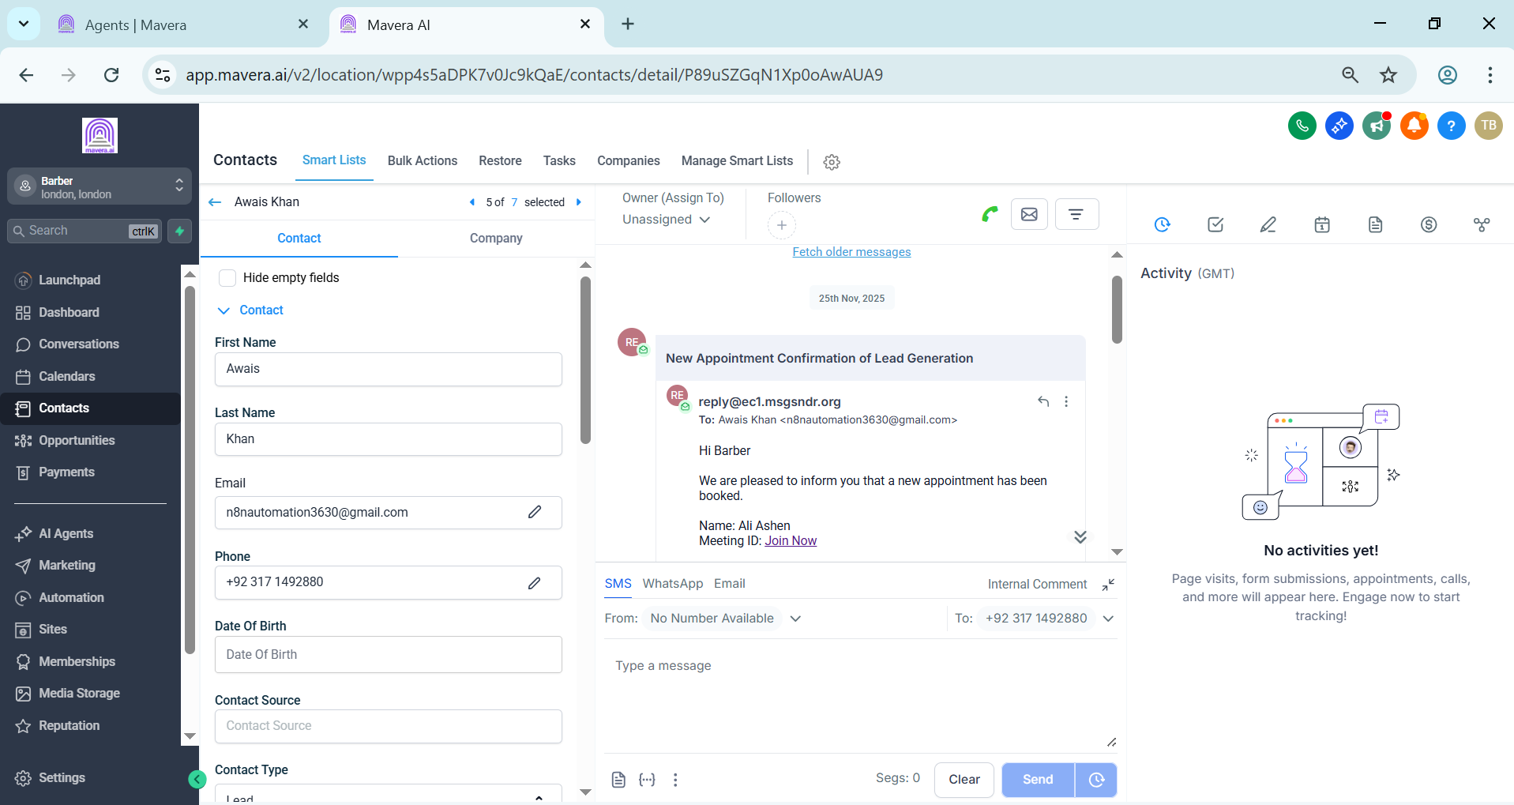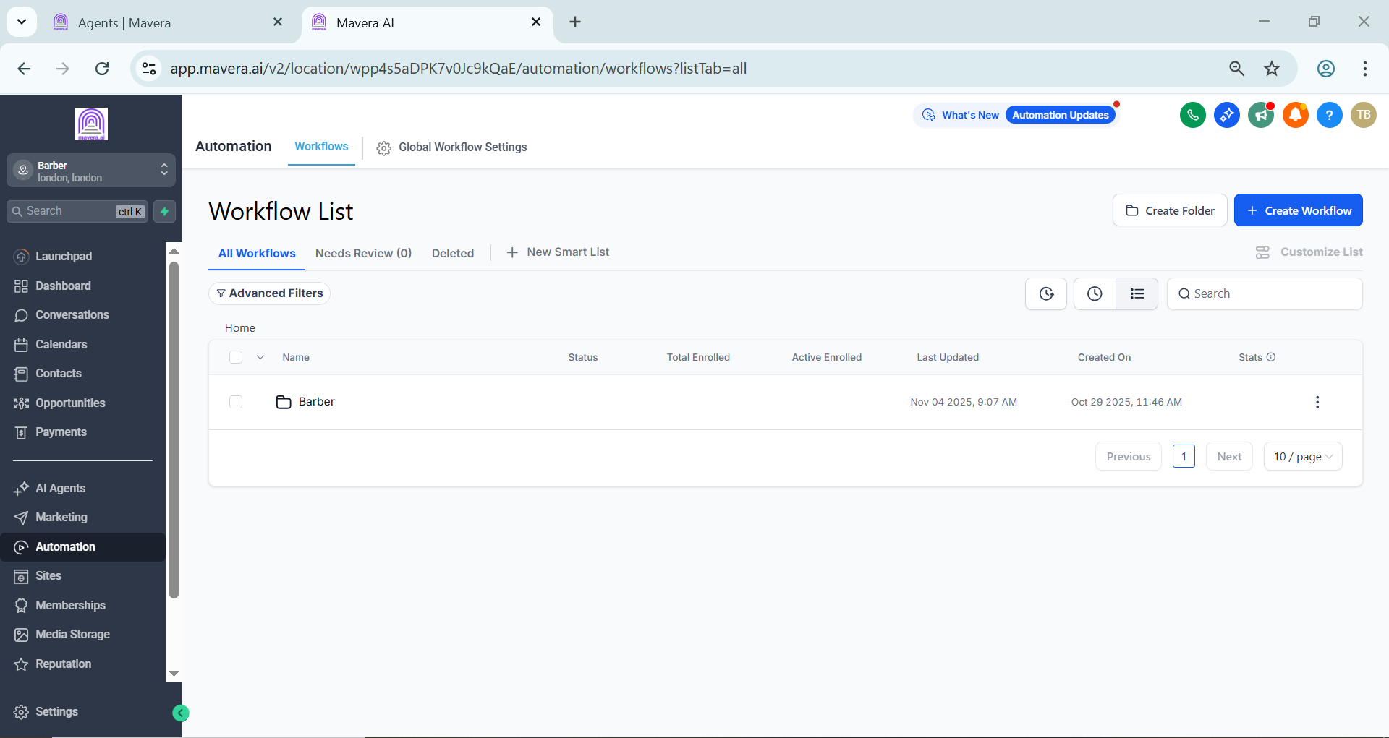

Voice Agent Setup
Configured dedicated voice agents for the Barber subaccount:
• Barber Inbound
• Barber Outbound
The agents are connected with the relevant inbound and outbound workflows.

Inbound Automation
The inbound setup includes:
• Inbound agent handling
• Appointment booking
• Post inbound data processing
• CRM updates

Outbound Automation
The outbound setup includes:
• Initial outbound calls
• Appointment booking
• Post outbound call data
• CRM updates
This keeps the outbound calling process organized from the initial call through the final outcome.

Appointment & Communication
Appointment activity is connected to the CRM so customer and booking information can be tracked in one place.
The system also supports automated appointment related communication through GoHighLevel.

Technology
• GoHighLevel
• Synthflow
• Voice Agents
• CRM Workflows
• Inbound Calling
• Outbound Calling
• Appointment Booking

Result
A centralized barber communication system connecting inbound calls, outbound calls, appointment booking, post call processing, and CRM updates in one setup.
The automation reduces manual calling and follow up work while keeping customer and appointment activity organized inside GoHighLevel.

